SONANCE LAUNCHES NEW OMNIDIRECTIONAL OUTDOOR LOUDSPEAKER AT ISE 2020

February 10 | ISE 2020, Amsterdam, Netherlands
Sonance, the inventor of the architectural audio category, announces that it is adding a new 70V/100V/8Ohm Omni-Directional Outdoor Loudspeaker that it says will deliver “sonic performance not previously experienced in this category”.

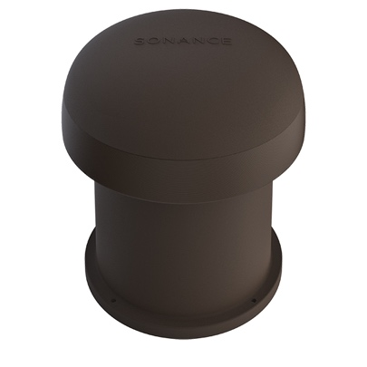
The Sonance Omni-6T, delivers 360-degree coverage in applications such as resort gardens, hotel pool areas, theme parks, outdoor shopping malls or residential backyards with large open areas.

It features a unique design that utilizes four x 1.25” (32mm) Wide-Band Drivers, in an array around the outside of the enclosure, to deliver full-frequency midrange and treble with 360-degree horizontal dispersion.

Bass augmentation is achieved via a 6.5” (165mm) high-excursion Woofer with Polypropylene Cone and Santoprene Rubber Surround, delivering a powerful and smooth low-end response.

A textured brown composite enclosure allows the speaker to blend seamlessly into ground cover, garden beds and foliage, while the top-ported design allows it to be buried up to 8” (203mm) deep, leaving only 6” (152mm) visible above-ground for even better camouflage. It features an all-weather construction that achieves Mil Spec 810, IEC 529, IP-66, allowing it to handle extremes temperature, moisture and even salt air.

It features Sonance’s Laminated Core Technology transformer (SLCT), delivering full-fidelity in either 70V or 100V mode with tap settings of 80W, 40W, 20W, (10W 70V only) and an 8 Ohm bypass.

The Omni-6T has a frequency range of 44Hz - 38Hz – 25khz, nominal sensitivity of 88 dB and a rated maximum SPL of 107dB @ 1 meter (3.3 feet) average, 113dB peak.

“Our goal was to build a competitively priced, Omni-Direction outdoor loudspeaker with the fidelity that Sonance is renowned for.” Said Simon Wehr, Director of Commercial Products for Sonance. “By utilizing this unique design, we are able to deliver sonic performance that was not previously experienced in this category,” he said.

Sonance Professional Series starts shipping in Q2 2020, and can be experienced live in the Sonance booth (1-N90) at ISE 2020 Amsterdam.

More information can be found at sonance.com
Media contact: Michael Bridwell michaelb@sonance.com
High res images: https://danainnovations.app.box.com/folder/99767320221

Sonance was founded in 1983 by Scott Struthers and Geoff Spencer, who introduced the world’s
first in-wall loudspeaker. This achievement led to many more “firsts” and a proud heritage of innovation.
It also inspired a philosophy that continues to drive the company’s brands today: that technology can
and should blend in with architecture and great design.

With a wide range of solutions that are designed to disappear, Sonance has cultivated long-standing,
authentic partnerships with leading architects, interior design professionals, custom installers, design-conscious consumers and end-users, from their home base in San Clemente, California and throughout
the world.

